Lab - Monitor and Manage System Resources in Windows

# Objectives

In this lab, you will use administrative tools to monitor and manage Windows system resources.

Part 1: Starting and Stopping the Routing and Remote Access service

Part 2: Working in the Computer Management Utility

Part 3: Configuring Administrative Tools

# Recommened Resource

* A Windows PC with internet access

# Instructions

## Starting and Stopping the Routing and Remote Access service

You will explore what happens when a service is stopped and then started. In this part, you will use routing and remote access service as the example service. This service allows the local device to become a router or a remote access server.

* + 1. Navigate to the **Control Panel** > Click **Network and Sharing Center**.

**Note**: If your Control Panel is set to **View by: Category**, change it to **View by: Large icons** or **View by: Small icons**. This lab assumes that you are using one of these settings.

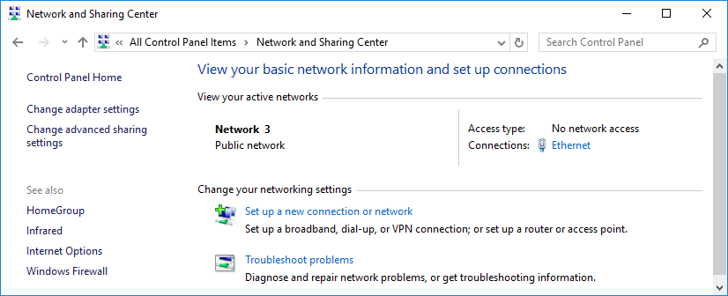

* + 1. Click **Change adapter settings** in the left pane. Reduce the size of the **Network Connections** window and leave it open.
    2. Navigate to the **Administrative Tools**. (Navigate to the **Control Panel** > Click **Administrative Tools**)
    3. In the **Administrative Tools** window, double-click the **Performance Monitor** icon.
    4. In the **Performance Monitor** window, make sure **Performance Monitor** under Monitoring Tool heading in the left pane is highlighted. Click the **Freeze Display** icon (pause button) to stop the recording.
    5. Right-click the graph and select **Clear** to clear the graph. Leave this window open.

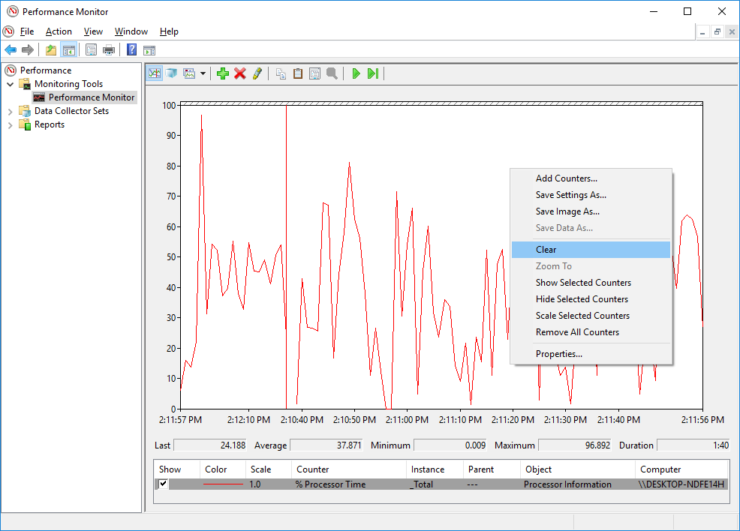

* + 1. Navigate to the **Administrative Tools** and select **Services**.
    2. Expand the width of the **Services** window so you have a clear view of the content. Scroll down in the right pane until you see the service **Routing and Remote Access**. Double-click **Routing and Remote Access**.

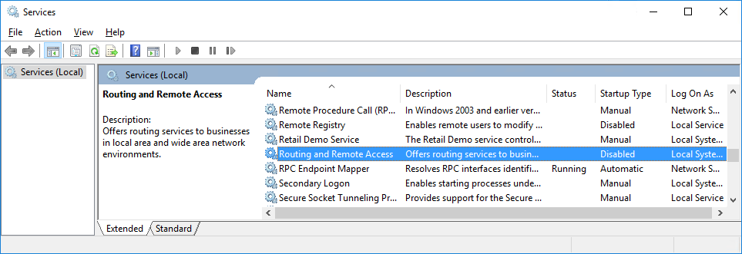

* + 1. In the **Routing and Remote Access Properties (Local Computer)** window opens. In the **Startup type** drop-down field, select **Manual** and then click **Apply**.

The Start button is now active. Do NOT click the Start button yet. Leave this window open.

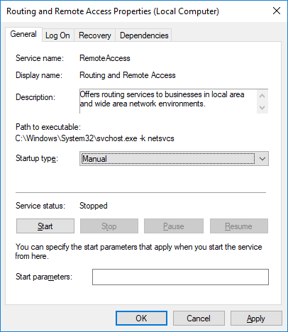

* + 1. Navigate to **Performance Monitor** window. Click the **Unfreeze Display** icon to start the recording.
    2. Click the **Routing and Remote Access Properties (Local Computer)** window. To start the service, click **Start**. A window with a progress bar opens.
    3. The **Routing and Remote Access Properties (Local Computer)** window now shows the Stop and Pause button active. Leave this window open.

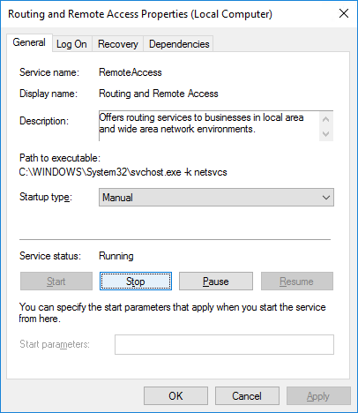

* + 1. Navigate to **Network Connections** window. Press the function key **F5** to refresh the content.

### Question:

What changes appear in the window after starting the **Routing and Remote Access** service?

Type your answers here.

* + 1. Navigate to **Routing and Remote Access Properties (Local Computer)** window and click **Stop**. **Note**: If **Stop** is greyed out, click **Apply** and change the service status.
    2. Navigate to **Network Connections** window.

### Question:

What changes appear in the right pane after stopping the Routing and Remote Access service?

Type your answers here.

* + 1. Navigate to **Performance Monitor** window and click the **Freeze Display** icon to stop the recording.

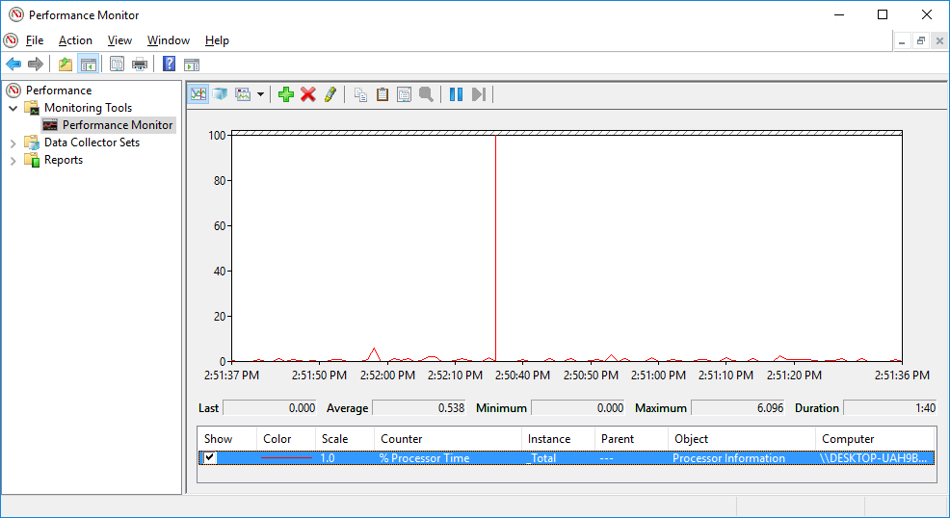

### Question:

Which Counter is being recorded the most in the graph (hint: look at the graph color and Counter color)?

Type your answers here.

* + 1. Click the **Change graph type** drop-down menu, select **Report**.

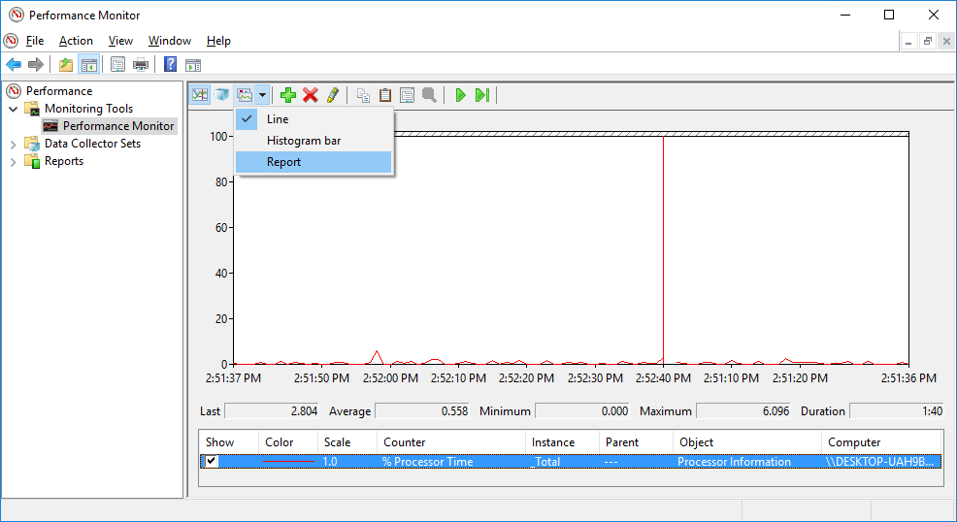

* + 1. The display changes to report view.

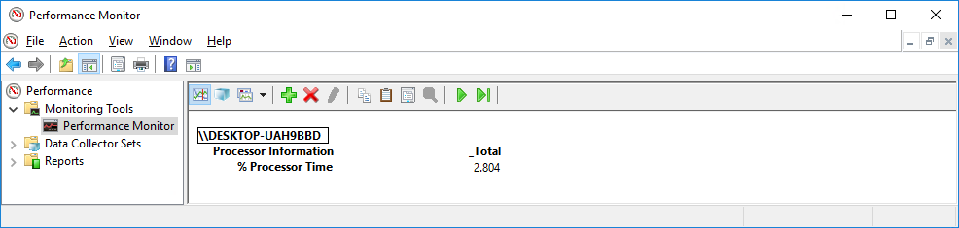

### Question:

What values are displayed by the counter?

Type your answers here.

* + 1. Click the **Routing and Remote Access Properties (Local Computer)** window. In the Startup type field, select **Disabled** and click **OK**.

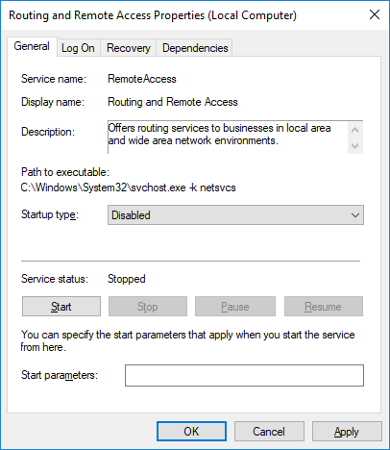

* + 1. Click the **Services** window.

### Question:

What is the Status and Startup Type for Routing and Remote Access?

Type your answers here.

* + 1. Click the **Performance Monitor** window. Click the **Unfreeze Display** icon to start the recording.
    2. Close all open windows you opened during Step 1 of this lab.

## Working in the Computer Management Utility

The Computer Management is used to manage a local or remote computer. The tools in this utility are grouped into three categories: system tools, storage, and services and applications.

* + 1. Click **Control Panel** > **Administrative Tools**. Select **Computer Management**.
    2. In the **Computer Management** window, expand the three categories by clicking on the **arrow** next to **System Tools**.
    3. Click the arrow next to **Event Viewer** then click the arrownext to **Windows Logs**. Select **System**.

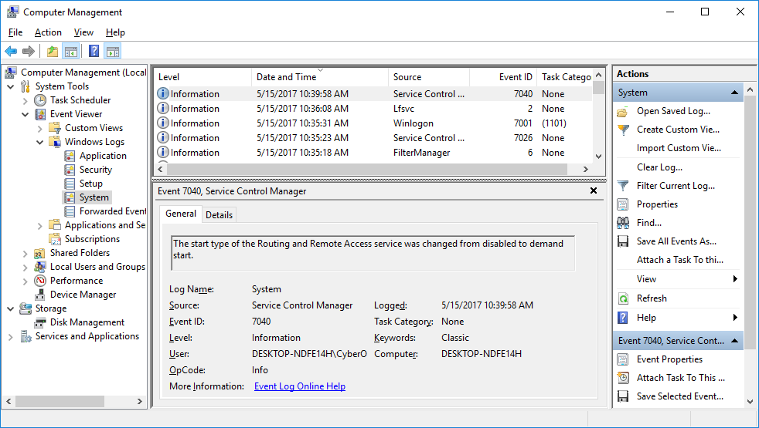

* + 1. The **Event Properties** window opens for the first event. Click the **down arrow** key to locate an event for **Routing and Remote Access**. You should find four events that describe the order for starting and stopping the **Routing and Remote Access** service.

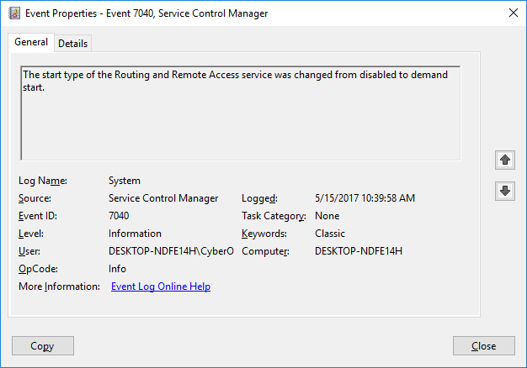

### Question:

What are the descriptions for each of the four events?

Type your answers here.

* + 1. Close all open windows.

## Configuring Administrative Tools

For the rest of this lab, you will configure Advanced Administrative Tool features and monitor how this affects the computer.

* + 1. Click **Control Panel** > **Administrative Tools** > **Performance Monitor**. The Performance Monitor window opens. Expand **Data Collector Sets**. Right-click **User Defined**, and select **New** > **Data Collector Set**.

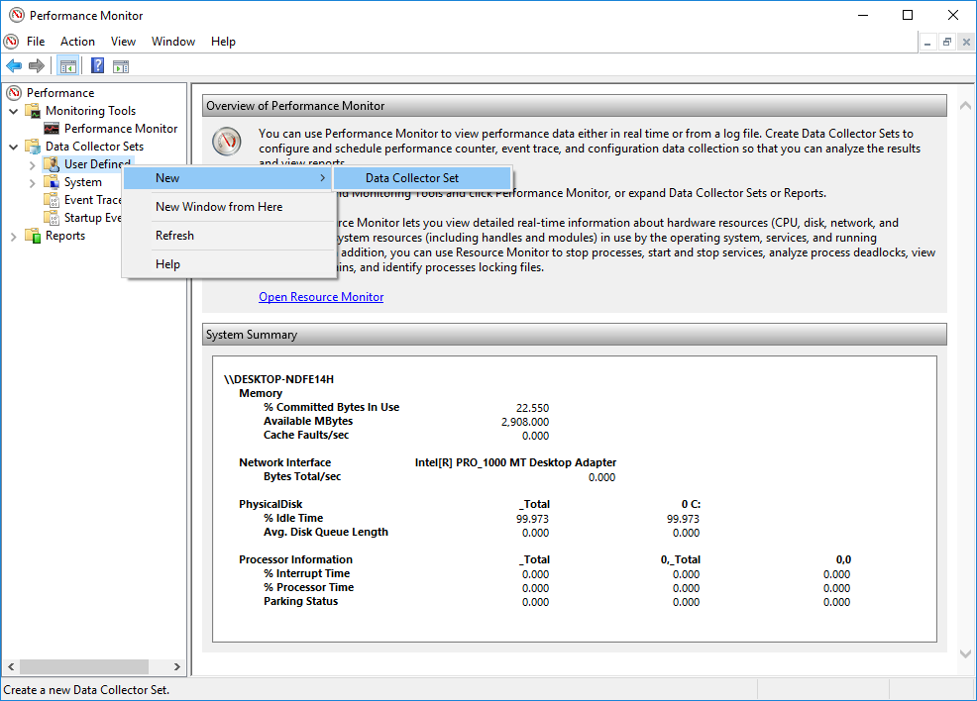

* + 1. The **Create new Data Collector Set** window opens. In the Name field, type **Memory Logs**. Select the **Create manually (Advanced)** radio button, and click **Next**.
    2. In the **What type of data do you want to include?** window, check the **Performance counter** box then click **Next**.
    3. In the **Which performance counters would you like to log?** window, click **Add**.
    4. From the list of available counters, locate and expand **Memory**. Select **Available MBytes** and click **Add>>**.

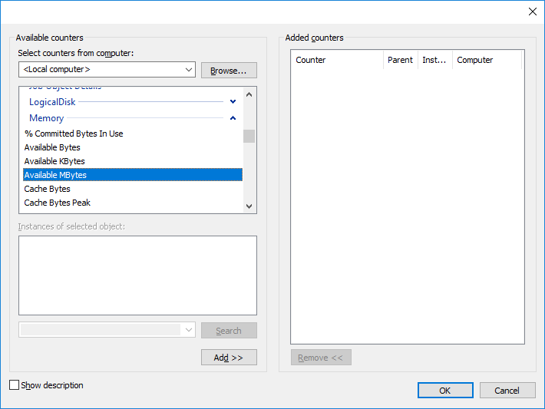

* + 1. You should see the **Available MBytes** counter added in the right pane. Click **OK**.
    2. Set the Sample interval field to **4** seconds. Click **Next**.

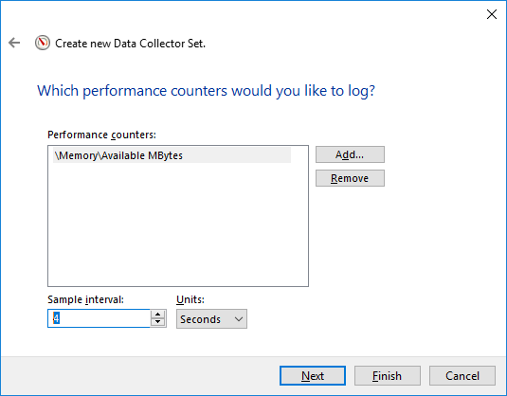

* + 1. In the **Where would you like the data to be saved?** screen, click **Browse**.
    2. In the **Browse For Folder** window , select your **(C:)** drive which is **Local Disk (C:)**. Select **PerfLogs** and click **OK**.
    3. The **Where would you like the data to be saved?** window opens with the directory information that you selected in the previous step. Click **Next**.
    4. In the **Create the data collector set?** screen, click **Finish**.
    5. Expand **User Defined** and select **Memory Logs.** Right-click **Data Collector01**and select **Properties**.

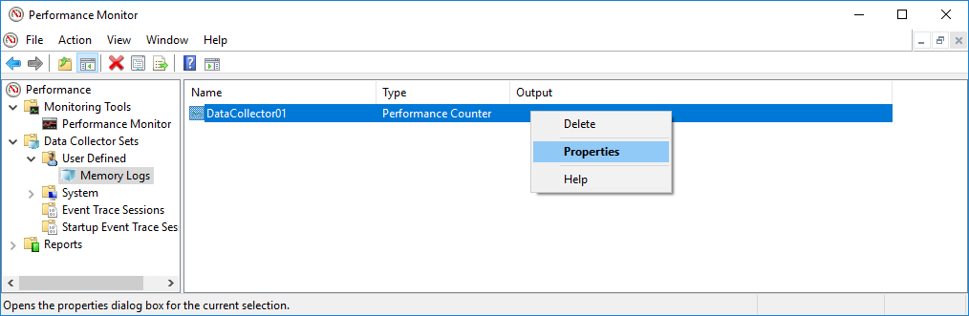

* + 1. In the **DataCollector01 Properties** window, chhange the **Log format:** field to **Comma Separated**.

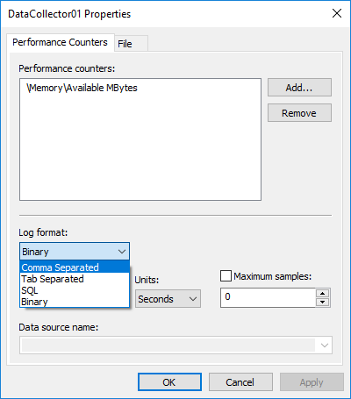

* + 1. Click the **File** tab.

### Question:

What is the full path name to the example file?

Type your answers here.

* + 1. Click **OK**.
    2. Select the **Memory Logs** icon in the left pane of the **Performance Monitor** window. Click the **green arrow** icon to start the data collection set. Notice a green arrow is placed on top of the **Memory Logs** icon.

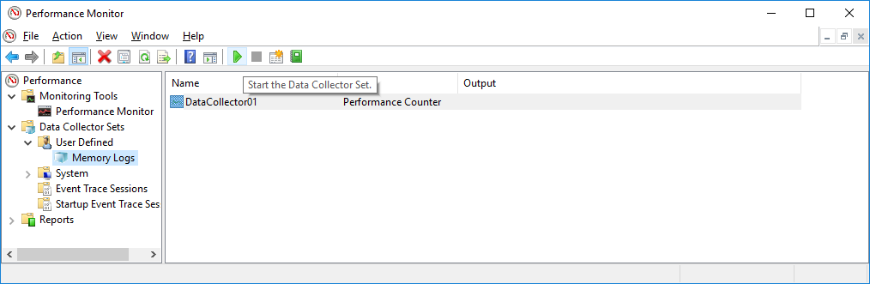

* + 1. To force the computer to use some of the available memory, open and close a browser.
    2. Click the **black square** icon to stop the data collection set.

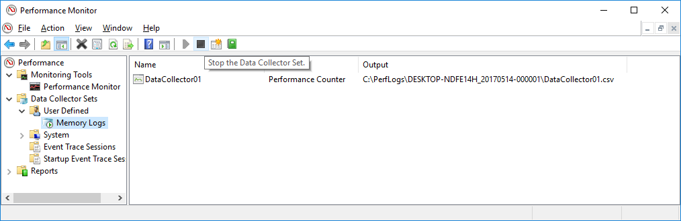

### Question:

What change do you notice for the Memory Logs icon?

Type your answers here.

* + 1. Click **Start > Computer**,and click **drive C: > PerfLogs**. Locate the folder that starts with your PC’s name followed by a timestamp, **DESKTOP-NDFE14H_20170514-000001** in the example. Double-click the folder to open it, and then double-click the **DataCollector01.csv** file. **If prompted, click Continue to permit access to the folder.**

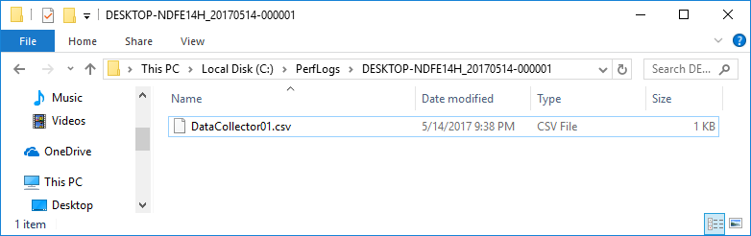

**Note**: If the **Windows cannot open the file**: message is displayed, select the radio button **Select a program from a list of installed programs** > **OK** > **Notepad** > **OK**.

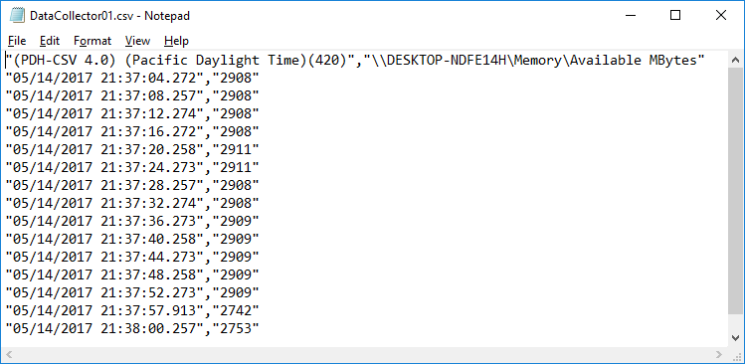

### Question:

What does the column farthest to the right show?

Type your answers here.

* + 1. Close the **DataCollector01.csv** file and the window with the PerfLogs folder.
    2. Select the **Performance Monitor** window. Right-click **Memory Logs** > **Delete**.

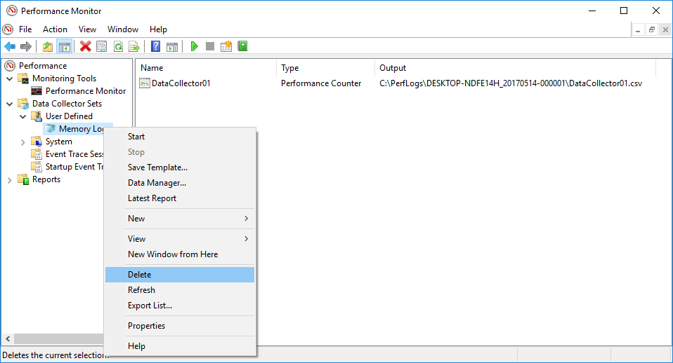

* + 1. The **Performance Monitor** > **Confirm Delete** window opens. Click **Yes**.
    2. Open drive **C: > PerfLogs** folder. Right-click on the folder that was created to hold the Memory log file, then click **Delete**.
    3. The Delete Folder window opens. Click **Yes**.
    4. Close all open windows.

End of document